Journal of Animal Ecology

Title: Birds control web-building spiders through direct predation and competition

Jeff Browna and Haldre Rogersa  
a. *Department of Ecology and Evolutionary Biology, Rice University*

**Abstract**:

Top predators can impact lower trophic levels through direct and indirect mechanisms. For example, birds are important top predators in systems around the world, and excluding birds in experimental studies consistently leads to a greater abundance of spiders. Yet bird exclosure experiments are unable to determine whether the increase in spiders is due to direct predation or indirect processes, such as releasing lower trophic levels from competition. To overcome this, we utilize an accidental experiment in the Mariana Islands to determine how birds control spider populations. Guam lost all native insectivorous forest birds with the introduction of the brown tree snake; web-building spiders are now more abundant on Guam when compared to surrounding islands. We seek to identify whether the increase in spider population can be attributed to direct predation or competition for shared prey. We tested the role of avian predators by comparing the survival of spiders inside versus outside bird exclosures Guam and a nearby island with a healthy bid population, Saipan. Spiders exposed to bird predators on Saipan survived a significantly shorter time than protected spiders. Additionally, spiders on Guam survived a similar duration as protected spiders on Saipan regardless of the presence of an exclosure. A comparison of per web prey capture rates between islands showed greater prey abundance on Guam, where birds are absent, than on Saipan. In summary, birds have a strong direct impact on spider population through predation, but they may also indirectly affect spider populations by competing for shared prey.

**Introduction**

Trophic cascades caused by the removal of top predators may lead to changes in lower trophic levels via multiple mechanisms. These include direct predation and release of intraguild predators from competition for shared prey. Direct predation may significantly reduce prey populations as seen when a decrease in sea otters led to an increase in sea urchins in the western Aleutian Islands (Estes and Palmisano 1974). Intraguild predators have more complicated effect on prey populations; the loss of an intraguild predator may benefit intermediate predators by decreasing direct predation and reducing competition for shared prey leading to an increase in prey availability (Costamagna and Landis 2006; Polis and Holt 1992). For example, in the Bahamas, lizards, and intraguild predator, limit spider populations more by outcompeting spiders for shared food sources than by directly predating upon spiders (Spiller and Schoener 1990). This competition limits the available food for the spider population reducing their reproductive rate (Sherman 1994).

Top down control of spiders by birds has been observed in systems throughout the world (Gunnarsson 2007). Bird exclosure experiments in canopy studies of western Australia have shown increase in spiders communities when birds are excluded (Evelegh, Majer, and Recher 2001). An exclusion of birds in spruce forests resulted in increased spider communities (Gunnarsson 2007). In the first landscape-level comparison of spider populations between forests with birds and forests on an island (Guam) without birds, Rogers et al (2012) found that spiders were 2 to 40 times more abundant in the absence of birds.

Birds may affect spider populations through direct predation or through competition for prey. Spiders are consumed by many bird species (Reichel et al. 2007; Jenkins 1983; Marshall, 1949; Ralph, Nagata, and Ralph 1985), thus direct predation likely plays a role in regulating spider populations. However, birds are intraguild predators of spiders, therefore while birds consume spiders, spiders also compete with birds for shared prey items. A meta-analysis of 113 studies shows that vertebrate predators reduce invertebrate predators, such as spiders, by as much as 38% but also reduce invertebrate herbivores by 39% leaving less invertebrates herbivores for the invertebrate predators to feed on (Mooney et al. 2010). The meta-analysis concluded that trophic cascades are strengthened by vertebrate intraguild predation (Mooney et al. 2010), suggesting that the result the loss of birds from an ecosystem could have strong cascading effects.

Nearly all studies of the top-down effects of insectivorous birds have used small-scale manipulative experiments, which have limited ability to identify the mechanism of top-down control. Bird exclosure experiments are typically conducted on individual branches, or in a few situations, on an entire tree (Gunnarsson 2007). However, although birds may be excluded from the exclosures, arthropods may move freely from areas with and without birds, possibly seeking out areas free from predation and with higher prey abundances. Additionally, adding exclosures may create more favorable environments for spiders by increasing the amount of substrate to attach webs to, or for prey items by reducing predation rate from excluded predators (Gunnarsson 2007).

In this study, we utilize an accidental experiment where all birds have been extirpated from the forests on one island to investigate the effect of bird predation and competition on spider populations. Accidental experiments such as these are useful for studying processes that operate on large spatial or temporal scales (HilleRisLambers et al. 2013). During the 1940s the brown tree snake was introduced to the island of Guam effectively causing the local extinction of all insectivorous forest bird species on the island of Guam (Wiles et al. 2003). This bird loss is correlated with a high abundance of spiders (Rogers et al. 2012). The nearby island of Saipan has healthy bird populations and a far lower abundance of web-building spiders. To investigate the role of direct predation by birds on spiders, we compared spider survival inside and outside of bird exclosures on Saipan, with birds, and on Guam, without birds. We compared the total number of days spiders survived, as well as the average web abandonment rate of spiders. To investigate the role of competition between birds and spiders for shared prey, we compared prey capture rates between webs in the forests of Guam and Saipan.

**Methods**

**Study Site and Species:**

The study was conducted on the islands of Guam and Saipan, located in the Mariana Island chain in the Western Pacific. These islands have an average temperature of 27 degrees C with little seasonal fluctuation (Camp et al. 2009; Lander and Guard 2003).The study was conducted in relatively undisturbed limestone karst forests on both islands. Sites were each a minimum of five hundred meters apart. Sites on the island of Saipan contain approximately 7 species of invertebrate-feeding birds, including the Nightingale Reed Warbler, the Micronesian Megapode, the Golden White-eye, and the Rufous Fantail. On Guam, no birds of any species are found in the forests where this study was conducted (Wiles et al 2003).

We focus on the species, *Argiope appensa*, also commonly known as the banana spider or garden spider. *A. appensa* is an orb-weaving spider from the family Araneidae which can be found throughout Oceania (Suman 1964), although it is likely not native to Guam (Kerr 1993). The organism was chosen for the study since it is found across the Mariana Islands, makes conspicuous webs, and is more abundant on Guam than on nearby islands with birds, ostensibly due to bird loss (Rogers et al. 2012). The species is common on edge and beach strand habitats on both Guam and Saipan (Kerr 1993), and is extremely common in the karst forests of Guam, but rare in karst forests on Saipan (Kerr 1993; Rogers et al. 2012).

*A. appensa* tend to remain in a single location unless facing environmental and biotic stressors (Li and Lee 2004). Typically, *A. appensa* spiders will consume their web before re-locating to a new position, likely because webs are made of protein-rich materials (Tanaka 1989). Reproductive females range in size from 15-25mm while males are generally less then 15mm in size. Webs are built anywhere from ground level to up to almost three meters up (obs 2013).

*Direct Predation Experiment*

We selected two areas of forest on Guam and Saipan to be used for direct predation experiments. At each area, we established a transect 100 meters long, with flagging every ten meters. The forest was similar in on both islands. Both areas were heavily covered with karst and dominated by similar tree species including Guamia, Aglaia, and Macaranga.

Since *A. appensa* was largely absent in the karst forests of Saipan, we were unable to use spiders from the karst forest. Instead we collected spiders in coastal areas where they were plentiful and translocated them into karst forests. We did this on both Guam and Saipan, even though spiders are common on Guam, in order to control for differences due to spider origin and for the effect of translocating spiders. Each *A. appensa* was captured along with its web, and placed in a Tupperware container. On both Guam and Saipan spiders were selected if they were at least one centimeter in body size as this generally indicates that the spiders are of a reproductive age (Wise 2006).

Spiders were released every 10 meters along the pre-established transect in karst forest within 24 hours after capture. Each released spider was observed until a web was established, at which point each web was flagged and labeled so that it could be re-identified, and every other web along the transect was enclosed with mesh bird netting to prevent bird predation. The bird netting was set up far enough away from the web so that it did not provide substrate for or otherwise interfere with web creation. Spiders, prey items, and other potential predators (e.g. geckos and skinks) could freely move into and out of the bird netting, but birds could not. A total of 40 spiders were released per island, 20 inside bird exclosures and 20 without the protection of a bird exclosure.

The webs were checked each morning between 5am and 8 am for eight days. Eight days was selected because 92% of spiders on Saipan not in exclosures were absent after eight days . The spider was considered to be absent if the spider was not in the web or surrounding three meter area. If a spider was absent, we recorded whether the original web was present or absent. We assumed predation had occurred if the web was present but the spider was missing, and we assumed that the spider was not predated, but abandoned the area if neither the web nor the spider was present (Tanaka 1989, observation June, 2014).

*Intraguild predation*To determine whether spiders on Guam captured more prey than those on Saipan, we recorded the number of prey items in webs on both islands. When counting prey capture insects smaller than a third of a centimeter were to be too small to be for prey and were considered incidental catch rather than prey (Murakami 1983).

We used the webs from the translocation study above (‘translocated webs’ = 40 webs per island) as well as webs naturally found in the karst forest on both islands (‘natural webs’ = 18 webs on Saipan, 219 webs on Guam). We selected natural webs on Guam by finding all spider webs within 2m of 17 randomly selected 30-m long transects. Transects within a site were at least 100m apart. On Saipan, we searched from every spider web we could find in the karst forest, since so few webs were found. Natural webs were found at ? separate sites on Guam and ? on Saipan.

Prey capture of translocated spiders was recorded daily until the spider disappeared or the study ended. Prey capture of natural webs was recorded once, when the transect was established. Observations were made between 7am and 2pm.   
*Analysis:*

To determine whether spider predation differed between Guam and Saipan, or between exclosure and control treatments, we used a generalized linear model and a model selection approach. The number of days each spider survived was the response variable and island (which correlates with the presence or absence of birds) and treatment (exclosure or control) as well as an island by treatment interaction were fixed effects. We used a Poisson error distribution, since the response was count data. We compared models using likelihood ratio tests and an. We again used a generalized linear model and model selection approach to determine whether there was a difference in the likelihood of predation versus web abandonment. Only data from webs lacking a spider were used. Web presence was the response variable and island, treatment and the island by treatment interaction were fixed effects. Binomial error distribution was used because the response was count data.

To investigate difference in prey capture between Guam and Saipan a generalized linear model was used. The response variable was the number of prey items found in web; island (corresponding to presence or absence of birds) was the fixed effect. Poisson error distribution was used and models were compared using likelihood ratio tests. Since translocated webs were revisited, the average prey capture was calculated and this average was used to represent the amount of prey the individual web captured.

**Results**:

Spiders within bird netting on Saipan survived longer than those outside bird exclosures (likelihood ratio test: p<<0.001), and there was no difference between spiders in and out of exclosure on Guam. In the situations where spiders were missing, the web was more likely to be present, indicating predation rather than abandonment, in both the open and exclosure treatments on Saipan than on Guam. This was particularly common in the open treatment on Saipan (p<0.0195). The spiders exposed to birds on Saipan showed a significantly higher daily abandonment rate than any other treatment:island combination (p<0.00426). This was calculated by comparing how often spiders were found

Significantly more prey items were found in webs on Guam than on Saipan (p<0.0449). On average about ten times the amount of prey items were found on Guam compared to Saipan with 0.963 +/- 0.100 items per web on Guam and 0.099 +/- 0.083 prey items per web on Saipan. Comparing translocated and non-translocated webs showed no signifance.

**Discussion:**

Avian predation is likely the strongest factor controlling *A. appensa* spider population in the Mariana Islands. On Saipan, an island with birds, few spiders survived more than a day without the protection of bird netting (Figure 1). The sedimentary nature of orb weaving spiders and the relatively large body size of *A. appensa* make it an easy target for birds (Kerr 1993). In addition, birds may learn to associate webs with food (Horton 1980). In other systems, spiders make up a significant percentage of insectivorous birds’ diets, especially in seasons where spiders are abundant and other prey items are scarce (Gunnarsson 2007). Avian predation on spiders has also been observed in the Marianas (Jansson and von Brömssen 1981).

Spiders also compete with birds for prey. Webs on Guam, which lacks forest birds, caught more prey than webs on Saipan, with forest birds. The release from competition allows more prey to be available to spiders which in turn should increase population growth rates (Wise 2006). Costamanga and Landis also show that release from competition for prey led to increased populations of arthropod communities (2006).

There may be additional ways birds affect spider abundance, which we did not investigate. For example, birds may cause increased web damage. Since reproduction is so costly, it is often limited or not undergone if the spider must use energy on web construction or relocation (Sherman 1994). The effect of birds may vary by season, as there are significantly fewer spiders on Saipan during the wet season than during the dry season. Bird may have different predation patterns during these seasons (Rogers et al. 2012).

Birds are not the only spider predators in the Mariana Islands, and thus bird loss may not be solely responsible for the increase in spiders on Guam. Lizards are able to move in and out of the bird exclosures, and Guam also has fewer tree skins and geckos than Saipan due to the brown tree snake (Fritts and Rodda 1995). This could explain the increased spider mortality in the exclosures on Saipan over those on Guam (Figure 2).

While multiple mechanisms may play a role in the regulation of spider populations by birds, direct predation is likely the most important. Direct predation eliminates individuals and reduces overall population growth (Caswell 2006). Competition also likely reduces the fitness of individual spiders, and thus affects spider populations, but this role appears to be secondary to direct predation. Reproductive rate in spiders is linked to prey capture but limiting prey capture in spiders does not eliminate the reproducing individual like predation does but instead reduces the rate at which the individual reproduces (Sherman 1994).

What are the implications of these results for the rest of the forest food web? Results from experimental studies on bird-driven trophic cascades have shown inconsistent effects of the top predators on primary producers. In theory, removal of the top predator from a food chain with 4-levels is predicted to result in increased survival or productivity of the primary producers, whereas removal from a food chain with 3-levels is predicted to result in negative effects on the primary producers. Mooney et al (Mooney et al. 2010) found that trophic cascades which occur as a result of the removal of a top predator are strengthened by intraguild predation. Here, we found evidence for a strong direct bird-spider interaction, which suggests that this system may be more similar to a 4-level food web, with positive impacts on plants. Continued research into the interaction strengths between birds and the multitude of bird and spider prey, as well as studies focused on the impact on plants, is needed to parse out the full impact of bird loss on the forest.

Acknowledgements:

I would like to thank the University of Guam for allowing me to use their field vehicle during this study as well as Lauren Thompson and Kyle Ngiratregd for their help collecting data

**References**

Camp, Richard J., Thane K. Pratt, Ann P. Marshall, Fred Amidon, and Laura L. Williams. 2009. “Recent Status and Trends of the Land Bird Avifauna on Saipan, Mariana Islands, with Emphasis on the Endangered Nightingale Reed-Warbler Acrocephalus Luscinia.” *Bird Conservation International* 19 (04): 323–37.

Caswell, Hal. 2006. “Matrix Population Models.” In *Encyclopedia of Environmetrics*. John Wiley & Sons, Ltd.

Costamagna, Alejandro C, and Douglas A Landis. 2006. “Predators Exert Top-down Control of Soybean Aphid across a Gradient of Agricultural Management Systems.” *Ecological Applications: A Publication of the Ecological Society of America* 16 (4): 1619–28.

Estes, James A., and John F. Palmisano. 1974. “Sea Otters: Their Role in Structuring Nearshore Communities.” *Science* 185 (4156): 1058–60.

Evelegh, N., Jonathan Majer, and H. Recher. 2001. “The Effects of Reducing Bird Predation on Canopy Arthropods of Marri (Eucalyptus Calophylla) Saplings on the Swan Coastal Plain, Western Australia.”

Fritts, T.H., and G.H. Rodda. 1995. “Invasion of the Brown Tree Snake”. National Biological Service.

Gunnarsson, Bengt. 2007. “Bird Predation On Spiders: Ecological Mechanisms And Evolutionary Consequences.” *Journal of Arachnology* 35 (3): 509–29.

HilleRisLambers, Janneke, Ailene K. Ettinger, Kevin R. Ford, David C. Haak, Micah Horwith, Brooks E. Miner, Haldre S. Rogers, et al. 2013. “Accidental Experiments: Ecological and Evolutionary Insights and Opportunities Derived from Global Change.” *Oikos* 122 (12): 1649–61.

Horton, Charles C. 1980. “A Defensive Function for the Stabilimenta of Two Orb Weaving Spiders (Araneae, Araneidae).” *Psyche: A Journal of Entomology* 87 (1-2): 13–20.

Jansson, Christer, and Anders von Brömssen. 1981. “Winter Decline of Spiders and Insects in Spruce Picea Abies and Its Relation to Predation by Birds.” *Ecography* 4 (2): 82–93.

Jenkins, J. Mark. 1983. *The Native Forest Birds of Guam*. American Ornithologist’s Union.

Kerr, Alexander M. 1993. “Low Frequency of Stabilimenta in Orb Webs of Argiope Appensa (Araneae: Araneidae) from Guam: An Indirect Effect of an Introduced Avian Predator”, October.

Lander, Mark A., and Charles P. Guard. 2003. *Creation of a 50-Year Rainfall Database, Annual Rainfall Climatology, and Annual Rainfall Distribution Map for Guam*. Vol. 20. Mangilao, Guam: Water and Environmental Research Institute of the Western Pacific.

Li, Daiqin, and Wan She Lee. 2004. “Predator-Induced Plasticity in Web-Building Behaviour.” *Animal Behaviour* 67 (2): 309–18.

Marshall,, Joe T. 1949. “The Endemic Avifauna of Saipan, Tinian, Guam and Palau.” *The Condor* 51 (5): 200–221.

Mooney, Kailen A., Daniel S. Gruner, Nicholas A. Barber, Sunshine A. Van Bael, Stacy M. Philpott, and Russell Greenberg. 2010. “Interactions among Predators and the Cascading Effects of Vertebrate Insectivores on Arthropod Communities and Plants.” *Proceedings of the National Academy of Sciences* 107 (16): 7335–40.

Murakami, Yasuaki. 1983. “Factors Determining the Prey Size of the Orb-Web Spider, Argiope Amoena (L. Koch) (Argiopidae).” *Oecologia* 57 (1-2): 72–77.

Polis, Gary A., and Robert D. Holt. 1992. “Intraguild Predation: The Dynamics of Complex Trophic Interactions.” *Trends in Ecology & Evolution* 7 (5): 151–54.

Ralph, Carol Pearson, Stephanie E Nagata, and C. John Ralph. 1985. “Analysis of Dropping to Describe Diets of Small Birds.” *Journal of Field Ornithology* 56 ((No. 2)): 165–74.

Reichel, James D., Charles T. Collins, Derek W. Stinson, and Vicente A. Camacho. 2007. “GROWTH AND DEVELOPMENT OF THE MARIANA SWIFTLET.” *The Wilson Journal of Ornithology* 119 (4): 686–92.

Rogers, Haldre, Janneke Hille Ris Lambers, Ross Miller, and Joshua J. Tewksbury. 2012. “‘Natural Experiment’ Demonstrates Top-Down Control of Spiders by Birds on a Landscape Level.” *Plos One* 7 (9).

Sherman, Peter M. 1994. “The Orb-Web: An Energetic and Behaviorual Estimator of a Spider’s Dynamic Foraging and Reproductive Strategies.pdf.” *Animal Behaviour* 48: 19–34.

Spiller, D A, and T W Schoener. 1990. “Lizards Reduce Food Consumption by Spiders: Mechanisms and Consequences.” *Oecologia* 83 (2): 150–61.

Suman, Theodore W. 1964. “Spiders of the Hawaiian Islands: Catalog and Bibliography.” *Pacific Insects* 6 (4): 665–87.

Tanaka, Koichi. 1989. “Energetic Cost of Web Construction and Its Effect on Web Relocation in the Web-Building Spider Agelena Limbata.” *Oecologia* 81 (4): 459–64.

Wiles, Gary J., Jonathan Bart, Robert E. Beck, and Celestino F. Aguon. 2003. “Impacts of the Brown Tree Snake: Patterns of Decline and Species Persistence in Guam’s Avifauna.” *Conservation Biology* 17 (5): 1350–60.

Wise, David H. 2006. “Cannibalism, Food Limitation, Intraspecific Competition, and the Regulation of Spider Populations.” *Annual Review of Entomology* 51 (1): 441–65.

**Figures and Tables**

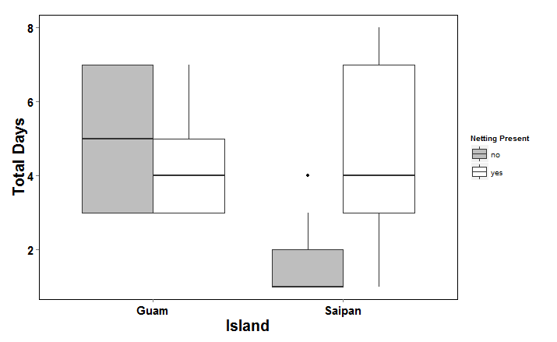

Figure 1: Comparison of spider survival inside and outside of bird exclosures in karst forests on Guam and Saipan.

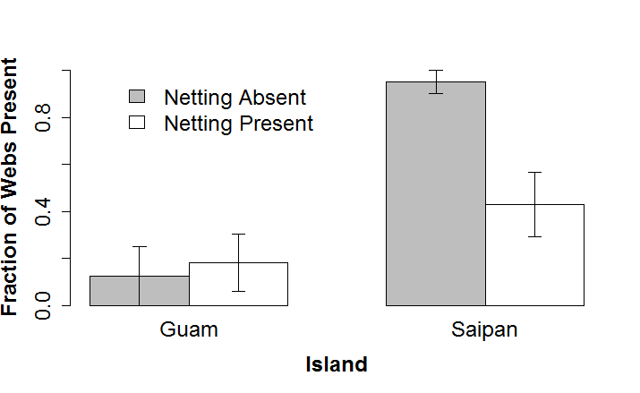**Figure 2:** The proportion of experimental units where the web was still present, given the absence of the focal spider. If the web is present, it is likely that the spider was preyed upon. Webs in which spiders survived until the end of the experiment were not included.

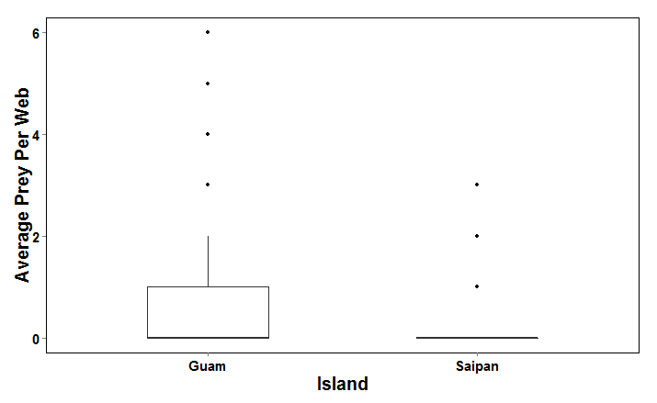

**Figure 3**: The average amount of prey items in spider webs on Guam and Saipan. The webs observed for these counts included both native webs and webs of spiders which where translocated into the native forest.

**Table 1:** Degrees of freedom andAkaike's Information Criterion for candidate generalized linear models assuming a Poisson distribution. The response for all models was spider survival.

|  |  |  |  |
| --- | --- | --- | --- |
| Model Number | Model parameters | Degrees of Freedom | AIC |
| 1 | island*netting | 4 | 234.3482 |
| 2 | island + netting | 3 | 251.5876 |
| 3 | island | 2 | 261.7141 |
| 4 | netting | 2 | 259.4130 |
| 5 | Null model | 1 | 270.9295 |

**Table 2:** Degrees of freedom andAkaike's Information Criterion for candidate generalized linear models assuming a binomial distribution. The response for all models was web presence/absence.

|  |  |  |  |
| --- | --- | --- | --- |
| Model Number | Model parameters | Degrees of Freedom | AIC |
| 1 | island*netting | 4 | 87.0946 |
| 2 | island + netting | 3 | 85.9471 |
| 3 | island | 2 | 86.4492 |
| 4 | netting | 2 | 91.6898 |
| 5 | Null model | 1 | 93.7329 |